Section D Team 5: Networked Appetite

Team Members: Anamika Kafle, Aakriti Neupane, Gaurab Rana, Mansi Deep, Bishwas Ghimire

Note: QSEE FILES ARE ATTACHED WITHIN THIS FOLDER

EERD

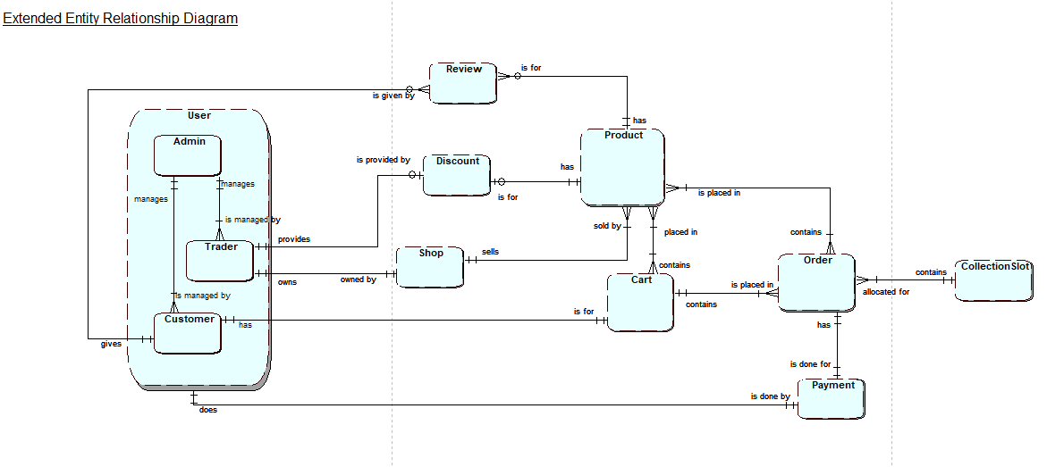

ERD

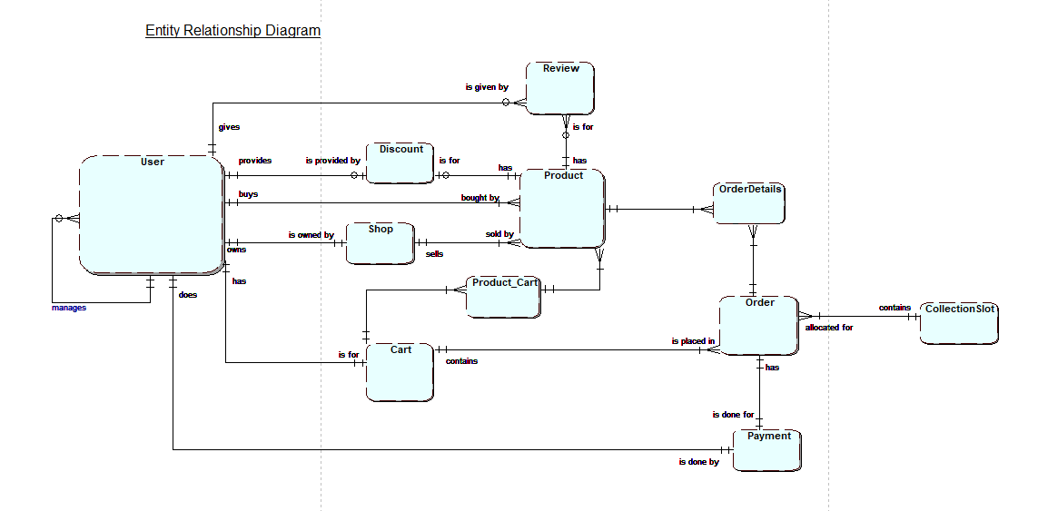

Composite ERD

